**Airline Reservation System Using Graph Database**

Aparna Kamble 1, Ajinkya Algonda 2, Rewati Sonar 2, Shital Jadhav 2, Supriya Bhagade 2

Asst. Professor, Dept. of Information Technology, MAEER’s MIT College of Engineering, SavitribaiPhule Pune

University, Pune, Maharashtra, India1

B.E Student, Dept. of Information Technology, MAEER’s MIT College of Engineering, SavitribaiPhule Pune

University, Pune, Maharashtra, India2

ABSTRACT :By conjunction of the world into a global village, travelling has become so common for not only business purpose but also for pleasure purposes. Due to the fast traverse nature of the world today, air travel is considered as one of the first preference among several modes of transportation or travelling to save time and one of the tools passengers use to speed up the process of travelling by air is the Airline Reservation System (ARS), especially passengers who don‘t have time to or don‘t want to visit a travel agent. Most airlines have offered their services over the World Wide Web. Therefore internet has become the most important part of the flight reservation process not only for travel agents, but also for the customers who want to book flights online without contacting airline agents. An Airline Reservation system is very essential because it has the strong power to reduce flaws that might have occurred when using a manual system of reservation and helps speed up the boarding process.

KEYWORDS Titan, Neo4j, Intellij, Graph database, Hadoop, Cassandra, Elasticsearch etc.

**I. INTRODUCTION**

We has seen the most technological environment in the last fifty years, with the advancement in every field have made the human life easier and more comfortable. Airlines industry has renowned into one of the most revolutionary and interesting industries of today’s world. Airline industry has completed the dream of humans to flying high in the sky. Today, millions of people fly every day. This has strengthened not only the economies of places but also connected people and cultures. The betterment of technology has led to big success in the area of flight ticket booking over the years.

Tickets are the one which can confirm purchase and guarantee a seat on the airplane for the desired journey. Tickets are nothing but the proof for getting the boarding pass at the airport, which is needed in order to board the airplane. The traditional tickets on the early days of airplane were made of paper and were to be collected from the travel agencies or airline office after booking. Along with globalization and the development of airline industry, the process of ticket booking has also changed and became easier. Due to the rapid growth and use of internet, the ticket booking has been possible online. The number of traditional paper ticket users is reducing day by day and the customers are moving towards the online tickets commonly known as e-tickets. A ticket contains the information about the passenger such as his/her name, date of travel, the flight number, destination and origin of travel, fare, taxes, information about baggage, rules about changes and refunds of money, mode of payments and the validity of the airline ticket.

In this paper, we will explain more details about our application, the users who can use this application, the system architecture and design, methodology, experimental results of software, conclusion and future scope of our application.

**II. Related work**

In[1] this paperauthor have stated that,

In recent years, the importance of storing and analysing data in the form of graph has been increasing. Graph database is now used in social networks, recommendation systems; biological network, web graph etc. and these graphs are highly interconnected. In relational database, data are stored in tabular form. For less connected or static data, relational database is perfect, but for highly connected data such as the network of hyperlinks in the World Wide Web, it is complex for representing in relational database. A similar kind of problem arises when we want to model the social networks like Facebook, Twitter etc. It has been accepted that the web data can also be represented and visualized using the graph database. The relational database and graph database are useful to represent data. Though, we compare graph database and the relational database, the graph databases appear to give better results. This means that we can more easily design and retrieve the results of queries if we use graph databases instead of using relational databases. When we want to add a new relationship to graph database, we do not need to restructure the database again. As we can see from our experiment, we get better results for executing the predefined queries in graph databases than in relational database with respect to time. The retrieval times for quires give us a conclusion that graph database is suitable to use in commercial purposes such as developing social network, stock market, and recommendation engine and network management.



Fig 1: Execution time for different queries for different objetcs[1]

In[2] this paper author have stated that,

Relational database is the type of database which is considered as a best choice for the applications such as data intensive storage and retrieval. Retrieval operation is usually done by using SQL database. Relational database systems is an efficient type of database unless and until the data contains many relationships requiring joins operation of large tables. Now a day there has been much interest in data stores that do not use SQL, so called NoSQL database. Examples are Google’s BigTable and Facebook’s Cassandra. This paper reports on a comparison of one such NoSQL graph database called Neo4j with a common relational database system, MySQL, for use as the underlying technology in the development of a software system to record and query data provenance information. In this paper the comparison of the relational database MySQL and the graph database Neo4j is shown from the point of view of storing a graph data. A directed acyclic graph (DAG) is a common data structure to store data provenance information relationships. The goal of this study was to decide whether a traditional relational database system like MySQL, or a NOSQL database system like graph database, such as Neo4j, would be more effective as the underlying technology for the development of a data provenance system. A graph is one of the fundamental data abstractions in computer science.

Both the systems performed comparatively well in their own area. In general, the graph database did better at the structural type queries than the relational database. In full-text character searches, the graph databases performed significantly better than the relational database. The fact that the indexing mechanism used in the graph database was

based on strings made the numeric queries less efficient. While a query on non-integer numeric data, such as doubles, was not included in the benchmark tests, the result would have likely been even worse for the graph database. The documentation on the Lucerne site suggests padding numeric with spaces or zeroes, as appropriate. While this works, it is too restrictive for the purpose of storing user-supplied parameters and values in the payload. In scientific data, it is not reasonable to set a particular precision level since some parameters might require two decimal places and others may require ten or more. Speed issues related to index searching in Neo4j for numbers are related to the Lucerne. This problem is known, and at the time of this writing, numerical indexing is being developed for Lucene. The other factor that must play a key role in choosing a database system for a data provenance system is security. The lack of support in Neo4j is an issue. Further investigation into Neo4j might yield workarounds to the search issues documented here. There are add-on components that allow Neo4j to be accessed as a Resource Description Framework (RDF) store, and potentially queried with SPARQL, an RDF query language, which has a W3C recommendation. That functionality is not well documented and was not tested in this study. Overall, for the data provenance project, it seems premature to use the graph database for a production environment where many queries will be on parameters stored in a semi structured way even in the face of Neo4j’s much better string searches. In addition, the need for securing user data is imperative. And lack of support in Neo4j is a significant drawback.

In[3] this paper author have stated that,

Current representation and storage systems are not very flexible in handling big changes and also they are not bothered with the ability of performing complicated and huge data operations. On the other side, the data manipulation systems can’t easily work with structural or relational data, but just with flat data representations. We want to bridge the gap between the two, by introducing a new type of database which is known as Graph Databases, based on a natural graph representation. The Graph Databases is used to represent the information in the form of graph structure, naturally serves changes in data, and this helps the Machine Learning methods to use the information. We are mainly bothered about the design and implementation of graph database in this paper. Thus, we define the Data Definition Language (DDL) and Data Manipulation Language (DML) that we use to write queries. In this paper it is shown that how to transform a relational database into a GDB. Here though the implementation is possible of all the mentioned queries, they do not implement all of these queries. This is a very difficult project that is much bigger than our class project goal. We have implemented the graph databases; have shown how we can execute the queries of graph databases, and the conversion of the relational databases into the graph databases too for the reuse of relational data stored previously. Our main aim is to design a new kind of database grew as an outcome of the problems arriving in autonomous dynamic environments that are very general in a lot of scientific domains, and also business domains, Internet etc. Previous existing database systems don’t take too much into account these problems, and they are not able to deal very well with changes. Also they do not provide a user friendly machine learning environment that will allow the recognition of patterns in the data, new concepts, behavioural explanation etc. Thus, our goal was to design such a system that would be very useful for machine learning applications, and in the same time be able to efficiently and uniformly store any general information, that could also change in time. Having these important things in mind, we have design the Graph Databases whose main building blocks are graphs representing uniform data, knowledge, models and queries. The priority for the graph structures came from the recent trend of using graphical representations of the data with the purpose of natural structure that data generally presents, which is good than the flat representations. The system that we are having is closed in spirit to OODB, but not the similar. As opposed to GDB, we do not accept any encapsulation, but we pay a price by having more Ids, which is not too much overhead for our purpose of easy manipulation of the data in a natural way. GDB is also somewhat similar to Datalog, the main difference being in our option of using IDs (links) instead of foreign keys. This is also main difference from ORDBMs and somewhat from XML. However we do not lose any kind of data by not using the foreign keys, and we show before how we can imitate them using IDs. Obviously, there are advantages and disadvantages in using GDB as a representation/storage/reasoning/learning system, but for our purposes the disadvantages (more memory storage) are not essential and we are willing to pay this price for the flexibility and integrated view that we get at the end. This is very much essential for the domains where we have to apply learning methods to get information from data. We are aware that a lot of the alive data inhabited in relational databases, and in order to be able to reuse this data, an important part in our project is concentrated on the transformation from relational databases format to our GDB input format.

**III. Proposed solution**

The proposed system is better and more efficient than existing System by keeping in mind all the drawbacks of the present system. The primary aim of the new system is to speed up the transactions and the query time by using the graph database. The query time of the proposed system will be reduced by using graph database because the graph database has less query time as compare to the SQL database. User friendliness is another characteristic of the proposed system. Messages are displayed in message boxes to make the system user friendly. The main Advantage of the proposed system is the minimum human power as it will be possible so search the details of various places. Each and every record is verified for the completeness and accuracy and then it is stored into the database. The comments and valid messages are provided to get away redundant data. Another very important feature of the proposed system is the data security provided by the system. The main objectives of the proposed system are:

* Complicated operations are done automatically
* Minimum processing time
* Simple and easy to manage
* Less chances of errors
* More accurate and faster than the existing system
* Report handling is easy

The proposed system is complete software for Airline Reservation System, Which is more efficient, reliable, faster and accurate for processing.

**IV. System architecture and design**

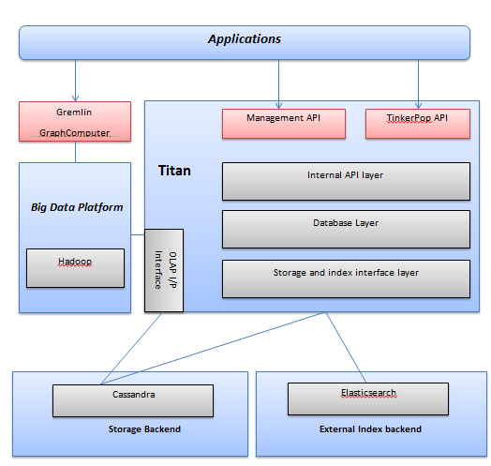

Fig 2: System architecture of the airline reservation system [62]

**BASIC CONCEPT OF GRAPH DATABASE:**

In computing, a graph database is a database that uses graph structures for queries with nodes, edges and properties to represent and stored data. A key concept of the system is the graph i.e. edge or relationship, which directly relates data items in the store. The relationships allow data in the store to be linked together directly, and in many cases retrieved with one operation. Graph databases, by design, allow simple and fast retrieval of complex hierarchical structures that are difficult to model in relational systems. Graph databases are similar to 1970s network model databases in that both represent general graphs, but network-model databases operate at a lower level of abstraction and lack easy traversal over a chain of edges. Compared with relational databases, graph databases are often faster for associative data sets and map more directly to the structure of object-oriented applications. They can scale more naturally to large data sets as they do not typically need costly join operations (here costly means when executed on databases with non-optimal designs at the logical and physical levels). As they depend less on a rigid schema, they are marketed as more suitable to manage ad hoc and changing data with evolving schemas.

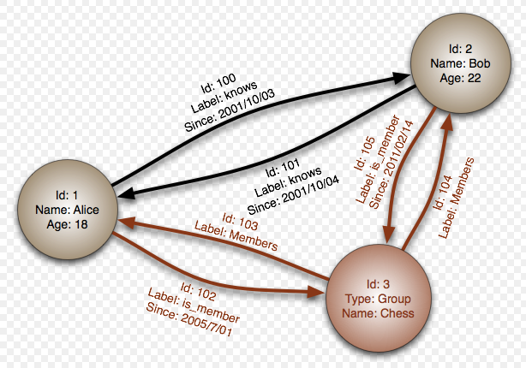

Fig 3: A Graph database[7]

**Graph database v/s relational database**

|  |  |  |
| --- | --- | --- |
| Parameters | RDBMS | Graph DB |
| Suitable for | Highly structured data | Highly related data |
| Stores data in the form of | Tables | Graphs |
| For each query | Traverse whole database | Travers only related nodes |
| Query time proportional to | Size of whole database | Size of the graph traversed |
| Complex query length | Very long | Short |

**Search operation in RDBMS v/s Graph database :**

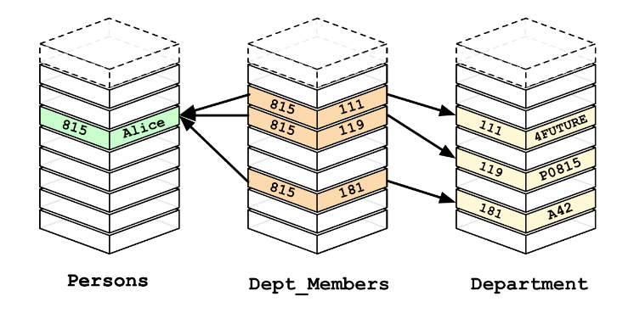

Fig 4 : Searching operation in Relational database[8]

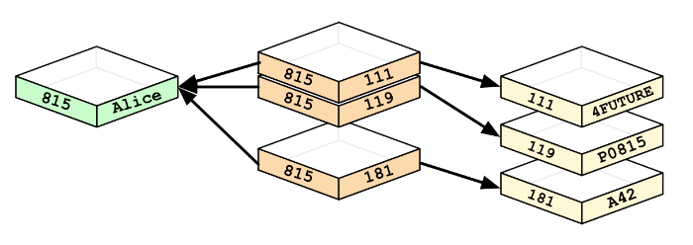

Fig 5: Searching operation in Graph database[8]

**Applications of graph database:**

1. Fraud detection:

2. Network and IT operations:

3. Master data management:

4. Social networking:

5. Real time recommendation engine:

6. Identity and access management:

**V. implementation procedure of the idea**

1. Search for the desired flight which you want to book by entering source and the destination of the journey.
2. Check flight availability.
3. If the flight is available go to step 4 else go to step 2.
4. Selection of flight and seat by the customer.
5. Fare will be provided to the customer accordingly.
6. The system will ask for the customer details.
7. Passenger has to enter the details whatever required.
8. Details will get verified.
9. If details of the customer are valid then go to step 10 else go to step 7.
10. Customer will pay the fare.
11. Admin will confirm reservation.
12. In case of cancellation of ticket the customer has to select cancel option.
13. The bank will refund money according to the cancelation policy.
14. Exit.

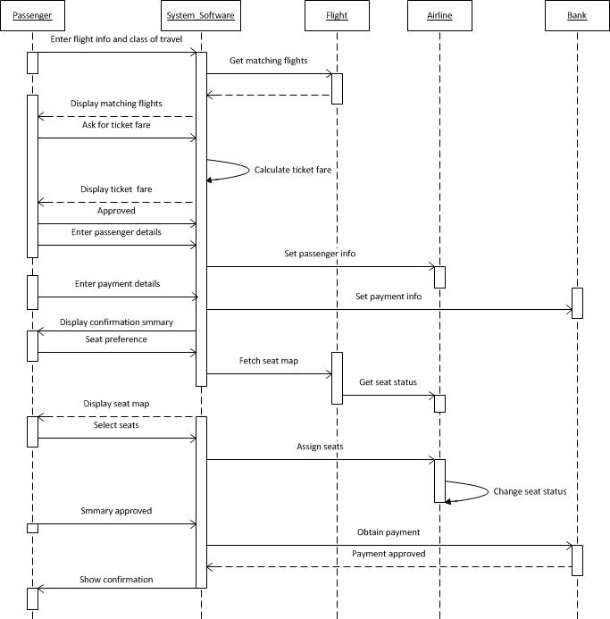

Fig 6 : Flow of the airline reservation system.

**VI. Conclusion**

The world has advanced in the area of internet technology. Even small tasks such as bill payments, online shopping and booking holidays can be done on the internet. The industry of airline has used the internet by having airlines reservation system. There is no doubt that the online airline reservation system is increasingly used by all for online flight booking. Though the high speed connection areas are the biggest users of this system now days, the internet reaching across the world is rapidly growing. Not only the airlines industries but also other travel and tourism industries have added even more features and enhance the online system of booking and other services.

In this system we have constructed the Airline reservation System, which enable the customer to check the availability of tickets and to book their desired tickets. This system helps customer to get the ticket online instead of standing in a long queue at the booking offices.

**References**

1. Surajit Medhi, Hemanta K. Baruah “Relational database and graph database: a comparative analysis”

2 .Chad Vicknair, Michael Macias, Zhendong Zhao, Xiaofei Nan, Yixin Chen, Dawn Wilkins “A Comparison of a Graph Database and a Relational Database”, ACM Southeast Regional Conference, 2010.

3. Adrian Silvescu, Doina Caragea, Anna Atramentov “Graph Databases”

4. S. Batra and C. Tyagi. Comparative analysis of relational and graph databases. International Journal of Soft Computing

5. B. Iordanov. Hypergraphdb: a generalized graph database. Web-Age Information Management, pages 25–36, 2010.

6. <http://s3.thinkaurelius.com/docs/titan/1.0.0/benefits.html>

7. <https://en.wikipedia.org/wiki/Graph_database>

8. <https://neo4j.com/developer/graph-db-vs-rdbms/>